How to Add a Dual Program
The Accreditation Data System (ADS) allows institutions to report on a dual preparation program when an institution identifies sponsoring two of their Commission-approved educator preparation programs in a dual or blended way (not to be confused with integrated undergraduate programs). All candidates enrolled in the dual program are concurrently earning the two identified credentials or authorizations.
If your institution offers one or more of the ‘dual credential’ programs identified on the Dual Programs Available on the ADS list, the Unit Head or Unit Head proxy can click on the Request a Missing Program button and request that the dual program be added to your institution’s list of Commission-approved programs. Steps to add a dual program can be found below.

If you are the Unit Head or Proxy and have created an ADS account but do not see your institution, contact annualdatasystem@ctc.ca.gov. Only CTC Staff can add a Unit Head or Unit Head Proxy to the ADS system.
Proceed with this user guide if you have been assigned with Unit Head permission.
STOP if you do not see your instituton listed or have not been assigned Unit Head permission. Contact annualdatasystem@ctc.ca.gov to be added.
Please note the Unit Head is the Dean or Superintendent, Proxy is one person designated by the Unit Head. An institution can desigamtate a Proxy by following the steps included in PSA 17-08.

- Navigate to the Accreditation Data System (ADS) log in page.  From the sign in screen, enter your email address and password, and click SIGN IN. | 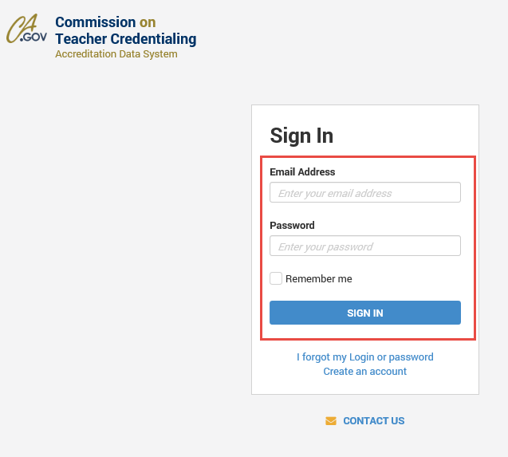
- Click the institution name (hyperlinked in the NAME column). | 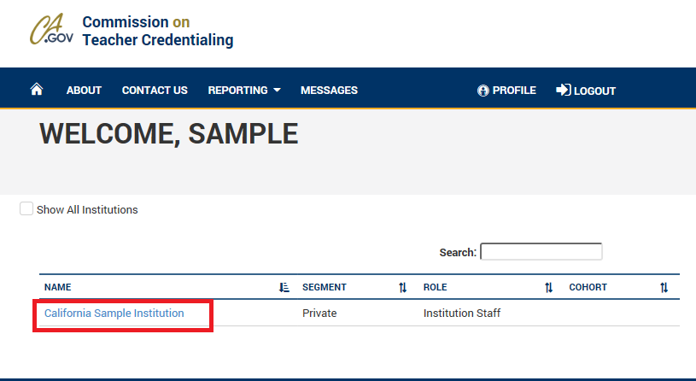
- Click the REQUEST A MISSING PROGRAM button to request the Commission to add dual programs for your institution.  A message window will appear. You must complete the message in full detail. | 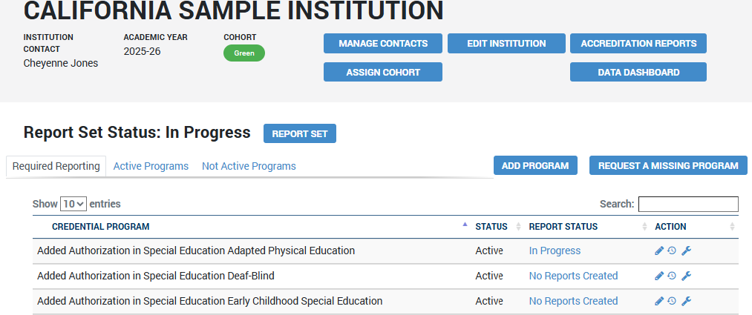
- Complete the message window and include all information regarding the request to add dual programs. Institutions can only request programs on the Dual Programs Available on the ADS list.  Select Request when complete. Allow 2-3 days for Commission staff to review and approve the request for your institution.  Once the request has been approved, the requester will receive an email from the Commission. |  | 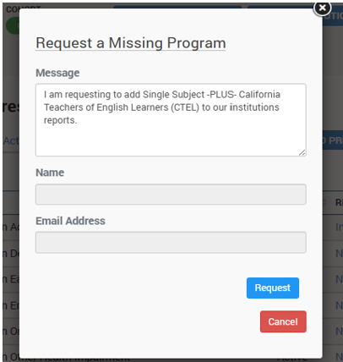
- When the dual program has been added to the list of active programs for your institution, begin creating report decks on the Report Set page.  For more information report decks, visit the Annual Data Submission page. |  | 