As an organization (school district, county office of education or charter), you will have the ability to submit an electronic misconduct report through the Educator Credentialing System (ECS) portal. A designated employee from each reporting organization will be required to obtain initial authorization from the Commission to submit misconduct reports via the ECS portal. Once authorization is approved, the granted employee can then provide and maintain access for other delegated employees within the organization with the ability to submit misconduct reports on behalf of the organization.

REQUESTING USER ADMINISTRATIVE ACCESS INSTRUCTIONS

To request User Administrative Access from Commission staff:
  - Visit the Report Educator Misconduct webpage.
    - If you are a school district or county office of education, please select Superintendent/Employing School Districts and select the Electronically Submit Misconduct Report button, to access the ECS Organization portal.

    - If you are a charter, please select Charter Schools and select the Electronically Submit Misconduct Report button, to access the ECS Organization portal.
  - Once the button has been selected, you should be directed to the ECS login page (Login | ECS Organizations).
  - Within the login screen, you will be prompted to select either a Microsoft or Google account, as reflected below. Enter your email address that is associated with your organization, which will be utilized for authentication purposes.

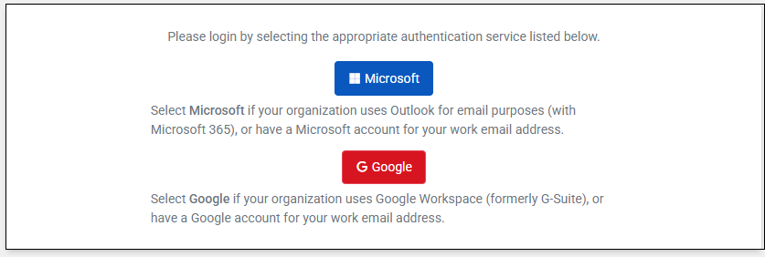
  - Once you enter your email address, your organization will populate. Select your organization for which you are requesting access, to enable your ability to submit misconduct reports by selecting on the 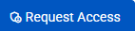 button. Once you request access, a Commission staff member will review it.

IF UNABLE TO LOCATE YOUR ORGANIZATION

  - If you are unable to locate your organization, you will see the image below. Please select the Contact Us link.

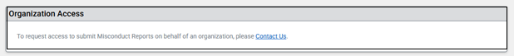

- Within the Contact Us link, select the option, I am a Public School Employer/ Program Sponsor and am inquiring about an educator or CTC Policy.
- From the Category drop-down, select the option Request User Access for Misconduct Reports and complete the populated form accordingly.
  - Once submitted, a Commission representative will be in touch to assist.

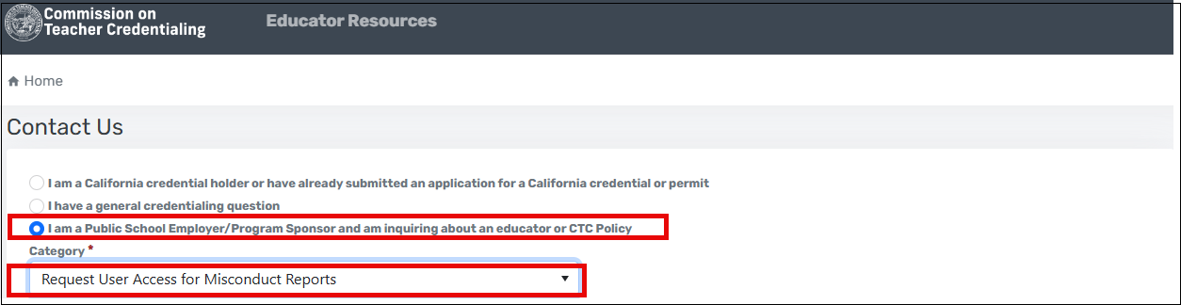

ONCE ACCESS IS REQUESTED

  - Commission staff will be notified to approve or deny your access request.
  - If access is denied, you will be notified and provided with a reason for the denial. If you believe access should be granted, you can resubmit your access request.

ONCE ACCESS IS GRANTED

  - If access is approved, you will be notified via email.
  - The initial organization employee (grantee) who requests user access from the Commission will be provided with user administrative access, which will allow the grantee to submit misconduct reports; in addition to delegating other staff the ability to submit misconduct reports. The grantee can then grant and monitor user access of its own staff. Please ensure that administrative access to others is limited.
  - Once access is granted, accessibility to the Misconduct Reports portal will be enabled, which will be reflected in the left navigation menu of the ECS Organization Portal, as reflected below:

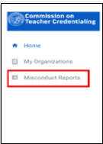

HOW STAFF CAN OBTAIN ACCESS FROM THEIR USER ADMINISTRATOR
There are two options that a grantee with user administrative access can provide access to delegated staff for report submission.
Option 1:
- The grantee can add the staff member’s user access through their Organization’s Security Account.
  - From the Organization account, select the Security Accounts tab.
  - Select Add Account and enter the email address for the delegated staff member; in addition to specifying the permission group, which will include two options:
    - Misconduct Report Submitters (this group can only submit misconduct reports).
    - Organization User Access Administrators (this group can grant other delegated staff with user access).
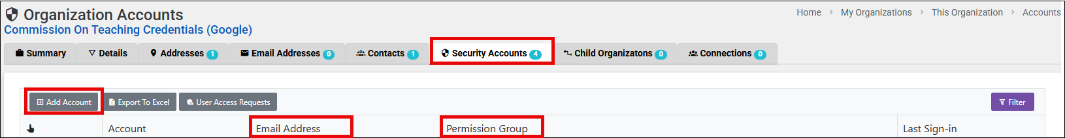

Option 2:
- The delegated staff member can log into the ECS Organization portal, and request access to their organization.

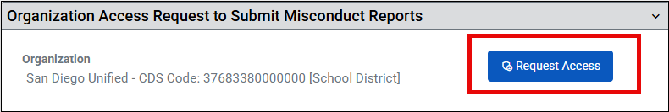

- Once access is requested, the administrator will receive an email notification where they can review User Access Requests through their Organization Security Account and grant access.
